Name: Krishna Ramani Student number: n01657309
Date: 22-04-2026

Lab 10: Microarchitectural Side-Channel Analysis

Objectives
- Understand the timing differences between CPU Cache hits and Cache misses.
- Observe the performance penalty of Branch Misprediction in modern x86 processors.
- Learn how to use the Time Stamp Counter (TSC) for high-precision microarchitectural auditing.

Part 1: Cache Timing Sensor
In this section, you will use cache_timing_sensor.c to measure the "gap" between a piece of data residing in the L1 cache versus data that must be fetched from main memory (RAM).

Key Functions to Investigate
- _mm_clflush(address): This intrinsic forces the CPU to evict a specific line from all levels of the cache.
- read_tsc_begin() and read_tsc_end(): These functions use the rdtsc instruction and lfence to ensure the CPU doesn't reorder instructions, which would ruin the timing measurement.

Instructions
- Compile and Run: Compile cache_timing_sensor.c using your platform's compiler (GCC/Clang or MSVC).
- Calibration: The program will attempt to calibrate your CPU's frequency using calibrate_cycles_per_second.
- Adjusting for Speed: If your machine has a high noise floor, you may need to increase the EXPERIMENTS constant to get a cleaner median.

Deliverables & Analysis
- Report: Provide the average/median hit time and miss time from your machine. Support it with a screenshot showing local computer time/date.
- Analysis: Why is the Miss/Hit slowdown usually significant (often 10x or more)?
- Analysis: Why do we use _mm_lfence() before and after reading the time stamp?

Part 2: Branch Predictor Audit
In this section, you will use branch_predictor_audit.c to measure the cost of "surprising" the CPU's branch prediction hardware.

Key Functions to Investigate
- run_training_window(): This function runs a loop 100 times, passing true for the first 99 iterations to "train" the predictor.
- measure_window(bool mismatch_on_last_branch): This measures how long the 100-iteration window takes when the 100th branch matches the pattern versus when it breaks it.

Instructions
- Compile and Run: Compile branch_predictor_audit.c.
- Training Pattern: Observe the code; it repeats the "99 hits, 1 possible miss" pattern across many repeated_windows.
- The Signal: The "Mismatch Penalty" represents cycles wasted flushing the pipeline due to incorrect speculation.

Deliverables & Analysis
- Report: Provide your observed Median mismatch penalty. Support it with a screenshot showing the local computer time/date.
- Analysis: If the branch predictor was 100% accurate, what would the mismatch penalty be?
- Analysis: How could an attacker use this timing difference to determine the value of a secret boolean variable in a victim program?

Troubleshooting Note
- Frequency Scaling: Ensure your laptop is plugged in and set to "High Performance" to avoid CPU throttling.
- Virtualization: If results show 0.00 cycles or massive noise, you may be in a VM where the rdtsc instruction is being intercepted by a hypervisor.

Grading

- Part 1 50/50
  - Report with valid screenshot 20/50
  - Analysis 30/50
- Part 2 50/50
  - Report with valid screenshot 20/50
  - Analysis 30/50

Part 1: Cache Timing Sensor

The objective of this experiment is to measure the difference between cache hit and cache miss timing using CPU timing instructions.
OUTPUT:
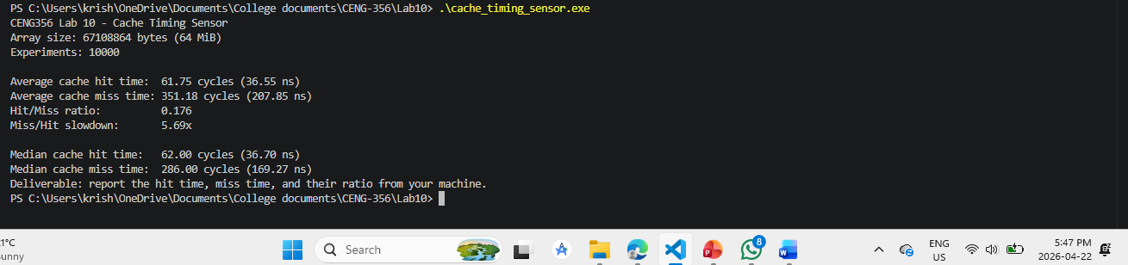

Average Cache Hit Time: 61.75 cycles (36.55 ns)
Average Cache Miss Time: 351.18 cycles (207.85 ns)
Hit/Miss Ratio: 0.176
Miss/Hit Slowdown: 5.69x

Median Cache Hit Time: 62.00 cycles (36.70 ns)
Median Cache Miss Time: 286.00 cycles (169.27 ns)

1) Why is the Miss/Hit slowdown usually significant?

- The slowdown is high because cache memory is very fast, while main memory (RAM) is much slower. When data is not in the cache (cache miss), the CPU has to wait longer to get it from RAM, which causes a big delay.
2) Why do we use _mm_lfence() before and after reading the time stamp?

- _mm_lfence() is used to make sure the CPU does not change the order of instructions. This helps in getting accurate timing results because the measurement happens exactly when we want it.

Part 2: Branch Predictor Audit

The objective of this experiment is to measure the performance penalty caused by branch misprediction in the CPU.

OUTPUT:
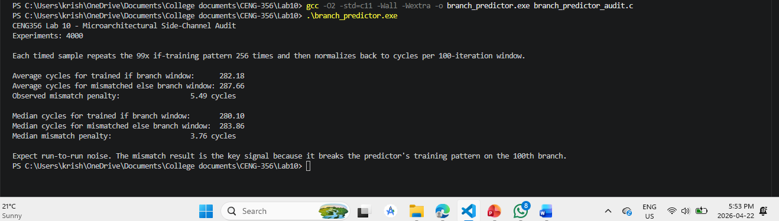

Average cycles (trained branch): 282.18 cycles
Average cycles (mismatched branch): 287.66 cycles
Observed Mismatch Penalty: 5.49 cycles

Median cycles (trained branch): 280.10 cycles
Median cycles (mismatched branch): 283.86 cycles
Median Mismatch Penalty: 3.76 cycles

1) If the branch predictor was 100% accurate, what would the mismatch penalty be?
- If the branch predictor was 100% accurate, the mismatch penalty would be zero because the CPU would not make any incorrect predictions.

2) How could an attacker use this timing difference to determine the value of a
secret boolean variable in a victim program?
- An attacker can use timing differences to guess secret information. By measuring how long different branches take to execute, the attacker can determine which path was taken and infer sensitive data.

